NEDSS Base System Design Overview:
Lab Report in PBP

Release 6.0
December 21, 2018


Prepared by:

U.S. Department of Health and Human Services

Version History
Version # | Author | Reviewed By | Revision Date | Revision Notes
1.0
0.2 | Fatima Lopez Calzado |  | 1/15/2019 | Document updated
0.1 | Fatima Lopez Calzado |  | 12/12/2018 | Initial version of this document.

Contents
1 Introduction 4
1.1 Purpose 4
1.2 Background & Scope 4
1.3 Document Organization and Usage 4
1.4 Key Terminology and Acronyms 6
2 Lab Report Overview 7
3 Linkage Workflow 7
3.1 Adding a new resulted test 8
3.2 Updating an existing resulted test 9
3.3 Viewing an existing resulted test 9
3.3.1 Generating next key 9
4 Key Linkage API 9
5 NBS459 Current Key 10
6 Hidden rowKey on each of the rows in the batch 10
7 PageSubForm in the session 11
8 Opening the Subform on View or Edit mode 11
9 Other new JavaScript method 13

Introduction

Purpose

This document provides an overview of the process followed within the NEDSS Base System (NBS) to handle different functionality on the new Lab Report page, like key linkage, new JavaScript methods, dropdown mapping, etc.
It includes:
- An overview of the purpose and usage of the Lab reports in PBP
- Workflow
- Key Linkage API
- Other JavaScript methods
- etc

Background & Scope
This document provides a high-level overview of the Lab Report Key linkage and describes the JavaScript functionality created in order to handle it, their purpose, and their behavior. The intended audience for this document is any user of the NBS that would like to:
- Develop, modify, create functionality related to the key linkage in Lab Reports in PBP.
- Be able to debug the Lab Report key linkage

Document Organization and Usage
This document includes the following sections:
Section | Description | Usage
Lab Report Overview | Provides basic information on key changed introduced in NBS 6.0 to support Lab report in Page Builder Pages | Read this section to better understand the new implementation of Lab Reports in 6.0
Workflow

Key Linkage API

Hidden rowKey on each of the rows in the batch

Hidden rowKey on each of the rows in the batch

PageSubForm in the session

Opening the Subform on View or Edit mode

Key Terminology and Acronyms

Key terminology and acronyms that are used in this document are described in the table:

Term | Acronym | Definition
Laboratory report in Page Builder Pages | Lab Report in PBP
Resulted Test
Susceptibilities
Isolate Tracking
RowKey
NBS459 or current key

Lab Report Overview

With NBS 6.0, the Lab Report module has been moved from Legacy pages to Page Builder Pages. Same functionality that was available from the legacy Lab Report, is now available from Lab report Page builder page which consists of 3 different templates:
- Lab Report
- Susceptibility
- Isolate Tracking

Linkage Workflow

The key linkage is used in order to associate the Resulted Test row with the susceptibility and isolate tracking information entered using the corresponding buttons. Those buttons are called: Manage Susceptibility and Manage Isolate Tracking:

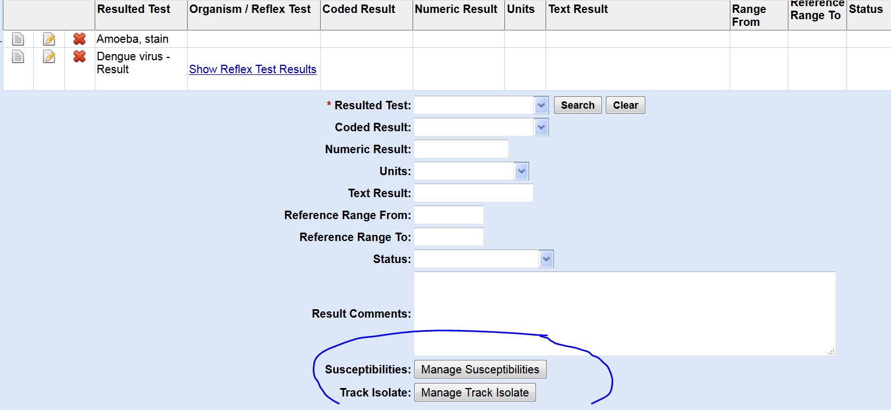

Every time a new resulted test is entered, and it has any susceptibility/isolate tracking information, those buttons are clicked in order to enter the corresponding information, for example, if Manage Susceptibilities button is clicked, it will open the following window:

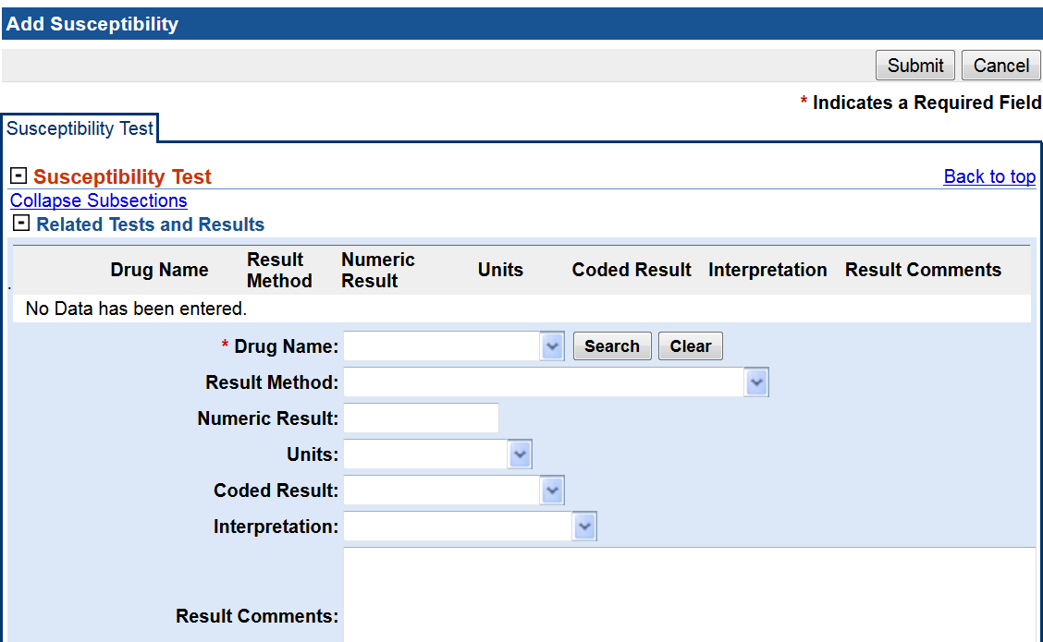

Which consists of a batch entry. Once the data is entered in the batch entry and submit is clicked, this information is stored in a new type of form: PageSubForm, and that subform is stored in the session, in the hashmap called subFormHashMap. Please, refer to the section Page Subform in session for more details about this HashMap. They key in this HashMap is what we call rowKey, which links the corresponding resulted test that we are adding/updating with the Susceptibility/Isolate subform.

Adding a new resulted test
If we are adding a new resulted test, at the beginning the NBS459 (hidden current key field) is empty. This field is filled as soon as Manage Susceptibilities / Isolate button is clicked so we use it as a reference for the whole resulted test.
If resulted test is added to the batch entry without entering any susceptibility/isolate tracking data, by the time the Add button is clicked, nothing is stored in the NBS459 field, but the system will generate the next available key and store it in the batch entry row.

Updating an existing resulted test

Since the rowKey is stored on each of the rows, every time the Edit icon of any row is clicked, the NBS459 hidden field will be populated with this value. Now if Manage Susceptibilities or Mange Isolate button is clicked, it will read the current key from this field in order to get the corresponding information from the session and show it in the windows.

Viewing an existing resulted test

It works similar to “Updating an existing resulted test” regarding the way the NBS459 field is populated every time the View Icon in clicked. The only difference is the Manage Susceptibilities / Manage Isolate tracking buttons will open the window in View Mode only.

Generating next key

If we are adding a new row in the batch entry, a new key number needs to be created. In order to do that, the method called getNextAvailableKey is used. It will check each key in the batch entry, getting the maximum number. The new generated key will be the maximum number found plus 1. That way, we don’t duplicate key numbers.

Key Linkage API

New methods for handling the currentKey (NBS459) field have been created in PageSpecific.js file. The methods are:

- getCurrentKey: reads the current key from the currentKey field
- emptyCurrentKey: empty the current key value from the currentKey field once it has been set in the batch entry row. This is called from setRowKey.
- getNextAvailableKey: get the next available key not used in the table
- getKey: get the key either from the currentKey field calling getCurrentKey or if there’s nothing, it gets the next available key not used in the table calling getNextAvailableKey. The key set in NBS459 will be the Key + _MODE_ + the actual mode (View or Edit)
- setRowKey: called from DMB_Generate_Generic_Index_JSP file, fillTable method in order to set the key in the hidden field in the batch entry row.
- getKeyNumberAssociatedToRow: returns the key value associated to the selected row by the id
- setCurrentKeyfromSelectedRow: sets the key value associated to the selected row in the hidden currentKey field.
- getMode: returns how the row was selected from the batch entry (if applicable). If it was selected from View icon, it returns View, if it was selected from Edit icon, it returns Edit.
- deleteKeyFromHashMapInSession: deletes the key from the hashmap that stores the pairs key – subFormPage.

NBS459 Current Key

The new hidden field with question identifier = NBS459 stores 2 important data:
- the key number: used to link the resulted test with the susceptibility and isolate tracking subforms stored in the session. It comes from the rowKey field stored on each of the rows in the batch entry, or it is generated as a new one if we are adding a new entry to the table.

- the mode: indicating how the row was selected from the resulted test batch entry: EDIT or VIEW. If mode is empty, it means we are adding a new entry to the table. It is used in order to know how to open the Susceptibility/Isolate subforms (View/Edit/Add mode).

Example: If the first row from the Resulted Test batch entry is selected clicking on view icon, NBS459 will store = 1_MODE_View. If Edit icon was clicked, NBS459 will store 1_MODE_Edit. For more information about this, please see the section called Opening the Subform on View or Edit mode

Hidden rowKey on each of the rows in the batch

In order to store the rowKey on each of the rows in the batch entry, the XSL files have been updated.
A new hidden field has been added to each of tables in the batch entry in order to store the corresponding key.
The XSL Files that have been modified are:
Files: DMB_Generate_Tab_JSP.xsl and DMB_Generate_View_Tab_JSP.xsl
The new code consists of adding a hidden input field which name is rowKey right before the View icon on the batch entry rows.
Code: <td style="display:none"><input name="rowKey" type="hidden" value=""></input></td>

PageSubForm in the session

The session stores the subFormHashMap HashMap, which pairs (pair,value) are (key – subForm). Isolate tracking and susceptibility subforms don’t share the exact same key, just the number (key) read from the currentKey field. For example, for currentKey = 1, the session stores, for the same resulted test:

- Susceptibility is stored as: (NBS_LAB222Button_1, PageSubForm)
- Isolate tracking is stored as: (NBS_LAB329Button_1, PageSubForm)

Opening the Subform on View or Edit mode

The NBS459 used to store the current key will also contain the “Mode”, which means the resulted test was selected from View icon or Edit Icon. This is used from Manage Susceptibilities and Manage Isolate Tracking buttons.
If the NBS459 contains: 1_MODE_Edit, this means: current key = 1 and Mode = Edit, and the Susceptibility window will show like:

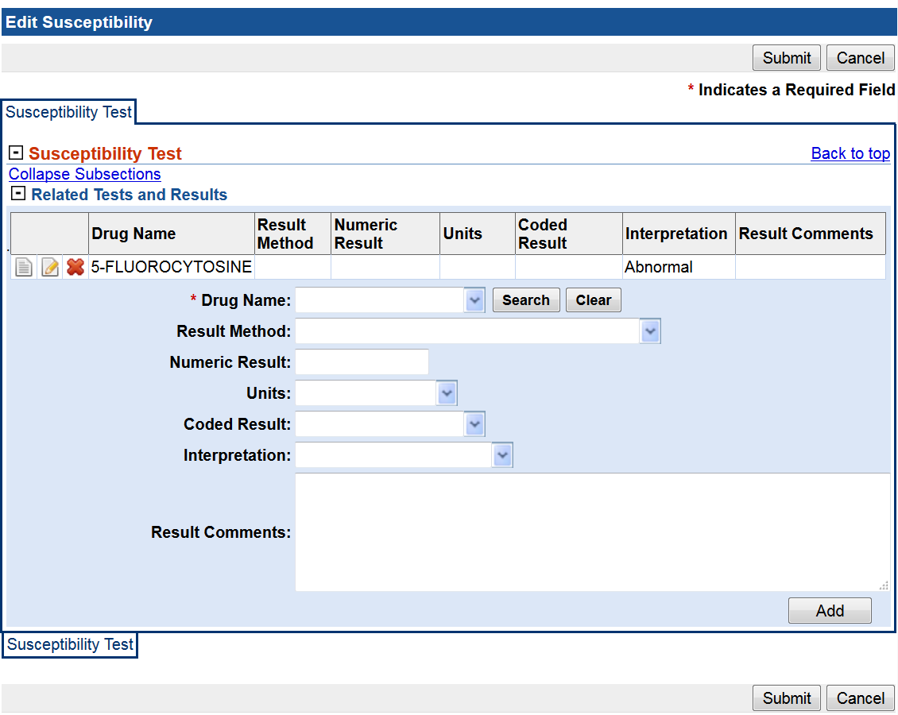

If the NBS459 contains: 1_MODE_View, this means: current key = 1 and Mode = View, and the Susceptibility window will show like:
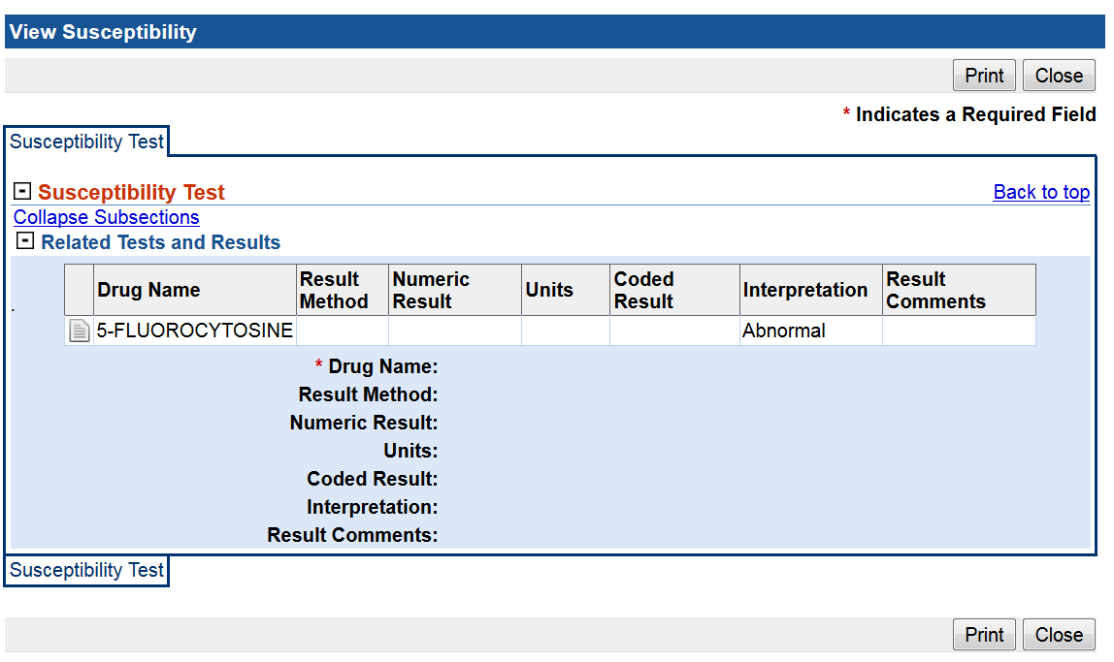

The JavaScript API contains a method in order to get the mode: function getMode().

Same thing is used from View Lab report.

Other new JavaScript method

In addition to the new JavaScript methods created in order to handle the key linkage, the following methods have been created:
New methods for populating dropdowns in lab report and susceptibility pages:
- populateResultMethodDataSusc
- populateCodedResultDataSusc
- populateCodedResultData
- populateDrugTestData
- populateOrganismData
- codeLookupLaboratoryReport: populates the values in Resulted and Ordered Test dropdowns.

JavaScript methods related to useful functionality on the screen:
- generateRowKeyValues: from view lab report, it generates consecutive integer numbers and assign them to the rowKey (hidden field on each of the resulted test rows)
- addSusceptibilityToResultedTestBatchEntry: adds the Show Reflex Test Result link to the corresponding sub section, and column.
- showHideOrganism: shows or hides the organism name depending of the resulted test value selected from the dropdown.
- clearDropdown: remove all the options from the specific dropdown id
Other JavaScript methods used for storing data in the backend:

- getAttributeMapFromScreen: returns an attribute map with the values from the screen corresponding to the question identifier received as a parameter. This is used from the XSL files, while writing the questions in the batch entry, for Resulted Test and Organism.
- setQuestionInAnswerMap: set questions of type 1031 like Ordered test (NBS_LAB112) in the answerMap. This is handled in a different way than the elements of type 1031 that are in a batch entry, like Resulted Test. They are already handled on the batch entry map.

